Date -02-04.2024

Topic : AMI across AWS regions, Copying Amazon EC2 AMI to different region, AMI Transfer

How to create a AMI

Go to your Instance >>> Actions >>> Image and Templates >>>> Create Image

Give your Image Name and description >>> Create

Now Go to AWS Account Console and Select your EC2 Instance created in a Custom VPC.

Lab

Region 1

Create a AMI of your Linux EC2

Choose your AMI >>> Action >>> COpy AMI

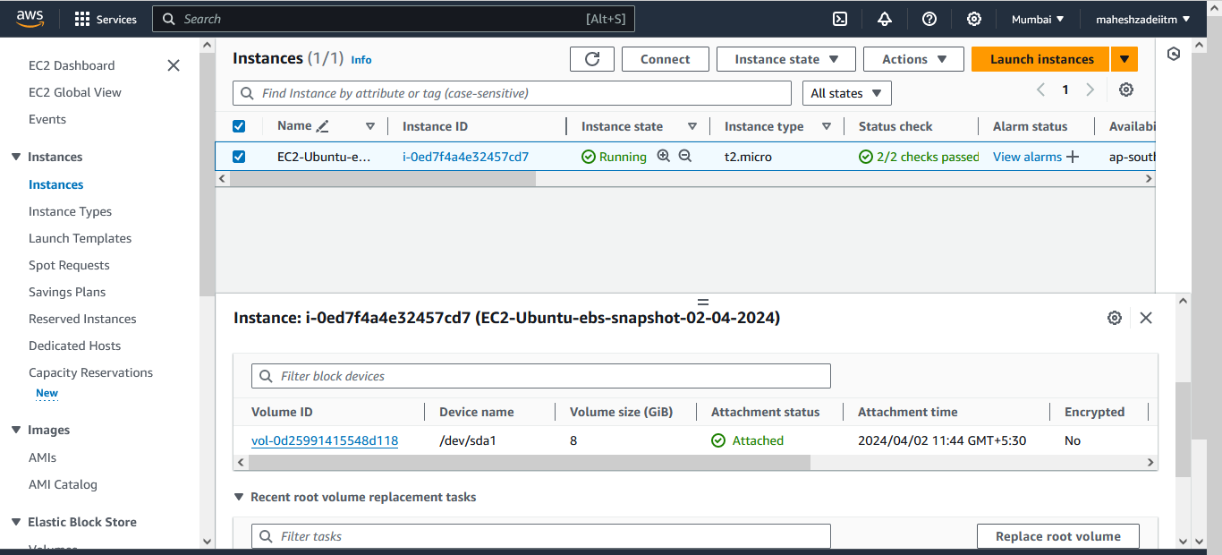

Select your EC2 Instacne >> Go to Action >> select image and Template >> create Image

Give the Image Name

Click on enable in No reboot option

Click on create image

Go to AMI Section on left side of the screen Check That AMI status is available.

This AMI we have created in Mumbai Region

Go to Action in AMI and select Copy AMI

Go to that new Region and See if that new AMI is copied or not

Launch a new EC2 in your Region 2 using "MYAMI"

Login to that EC2 instance

Create a File

or Create a user

or Install a application

or do whatever you want

Again - Create a AMI out of this new EC2 in the Region 2

COpy this AMI to the Region 3

Now Select the Destination Region Asia pacific (Hyderaba)

And click on copy Tag

Then click on Copy AMI.

AMI Cpy operation is initiated

Now Go to Hyderabad region AMI Option

Now check the status till available

Once it is available we will create the EC2 Instance

Give the name to AMI

Check the Status

Now create the EC2 Instance in Hyderabad Region

Click Launch instance from AMI

Give the instance name

Select the free tier instance type

Download the keypir for Hyderabad region

Select default network settings

Select security group default

Click on Launch Instacne

EC2 Instance is created.

Now copy public IP to connect the instance

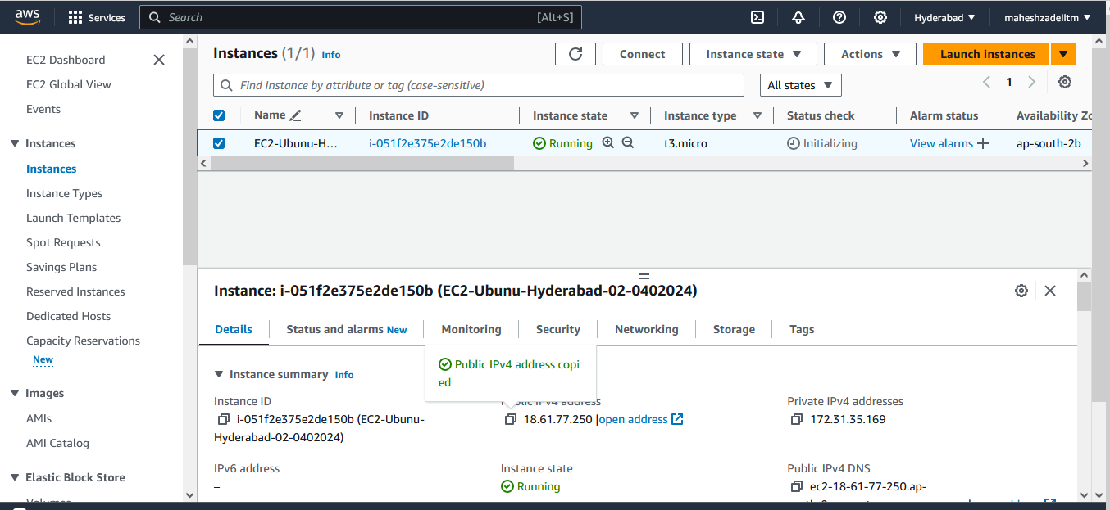

Open mobasterm

Copy public IP

Type user name ubuntu

And browse private key for Hyderabad region.

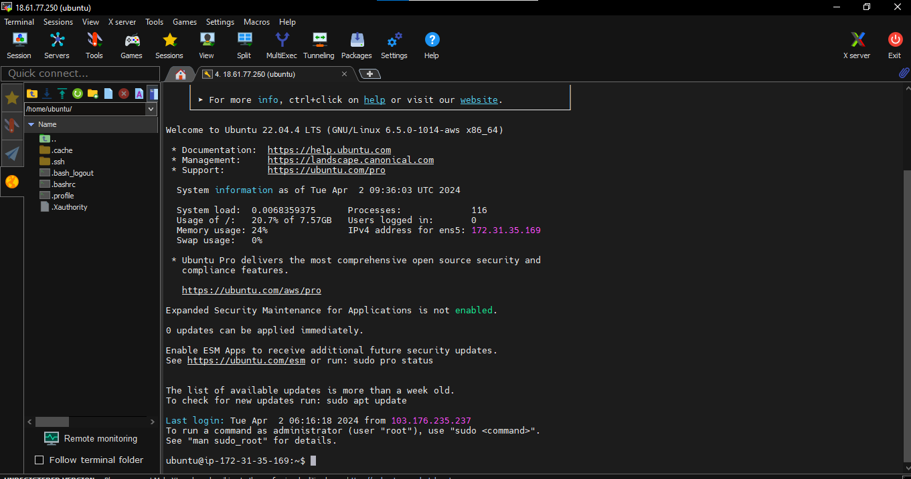

Now I have crated maheshzade folder and inside this 1.txt file created .

Now create the AMI in 3rd Region Hong kong

Select the EC2 Instacne in Hyderbad Region and go to action then select image and template and click create image

Click on create Image

Choose your Region 2

Copy AMI

Launch a new EC2 in the Region 3

Login to this new EC2 and validate whatever you have done in the 2 EC2 whether they are available in the 3rd EC2 or not .

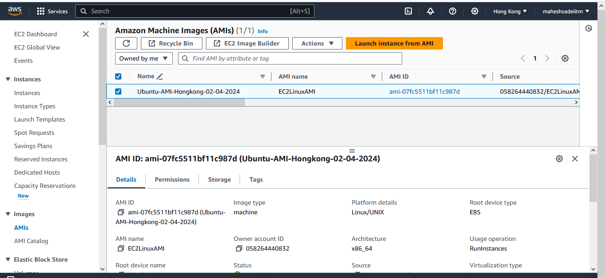

Check the status is available or not .

Click on launch instance AMI

Give the Name of EC2 instacne

Select the instance type t2.micro.

Click on launch instance

Copy Public IP paste in Mobasterm



